CIVIC-SENSE- Public Grievance and Sentiment Analysis System

A Project Report Submitted in t
he partial fulfillment of the requirements for the award of the degree of

BACHELOR OF TECHNOLOGY
In

DEPARTMENT OF CSE
By
B. Chetna Chaudhary | :2420030098
J. Nandini | :2420030262
S. Sai Saranya | :2420030266

Under the Esteemed Guidance of

Dr N SUNANDA

Associate Professor

Department of CSE

AY-[2026-2027]

Semester:5




K L (Deemed to be) University DEPARTMENT OF CSE

Declaration

We hereby declare that the project report entitled “CivicSense – Public Grievance and Sentiment Analysis System” is a bonafide record of the work carried out by the undersigned students under the guidance of [Guide Name], in partial fulfilment of the requirements for the award of the degree of Bachelor of Technology in Computer Science and Engineering at K L (Deemed to be) University.
We further declare that the work presented in this report is based on the implementation available in our project repository and that all external resources used have been acknowledged appropriately.

B. Chetna Chaudhary | :2420030098
J. Nandini | :2420030262
S. Sai Saranya | :2420030266

`

K L (Deemed to be) University
DEPARTMENT OF CSE

CERTIFICATE

This is to certify that the project report entitled "CIVICSENSE – PUBLIC GRIEVANCE AND SENTIMENT ANALYSIS SYSTEM" is a bonafide work carried out and submitted by Batta Chetna Chaudhary (2420030098), J. Nandini (2420030262), and S.Sai Saranya (2420030266) in partial fulfillment of the requirements for the award of the degree of BACHELOR OF TECHNOLOGY in the Department of Computer Science and Engineering, Koneru Lakshmaiah Education Foundation (Deemed to be University), during the academic year 2026–2027.

_____________________  Signature of the Guide  Dr. N. Sunanda  Associate Professor, CSE | _____________________  Course Coordinator  Dr. N. Sunanda  Department of CSE | _____________________  Head of the Department  Dr.P. Venkateswara Rao  Department of CSE

ACKNOWLEDGEMENT
The success in this project would not have been possible but for the timely help and guidance rendered by many people. Our wish to express my sincere thanks to all those who has assisted us in one way or the other for the completion of my project.
Our greatest appreciation to my Course Coordinator and my guide Dr.N.Sunanda , Department of CSE which cannot be expressed in words for his/her tremendous support, encouragement and guidance for this project.
We express our gratitude to P. Venkateswara Rao , Head of the Department for CSE for providing us with adequate facilities, ways and means by which we are able to complete this project-based Lab.
We thank all the members of teaching and non-teaching staff members, and also who have assisted me directly or indirectly for successful completion of this project. Finally, I sincerely thank my parents, friends and classmates for their kind help and cooperation during my work.

B. Chetna Chaudhary | :2420030098
J. Nandini | :2420030262
S. Sai Saranya | :2420030266

Abstract
CivicSense is a data science-based public grievance and sentiment analysis system designed to organize and analyse citizen complaints related to essential public services. Citizen grievances are often submitted as unstructured text. Reading and sorting a large number of complaints manually can be time-consuming and may make it difficult to identify recurring problems, public dissatisfaction and high-priority issues.
The system applies Natural Language Processing (NLP) techniques to clean complaint text and convert it into numerical features using Term Frequency–Inverse Document Frequency (TF-IDF). A Logistic Regression classifier is used to classify complaints into eight public-service categories: Roads, Water Supply, Electricity, Healthcare, Education, Transportation, Drainage / Sewage and Other Public Services. A separate sentiment model identifies each complaint as Positive, Negative or Neutral.
CivicSense also provides data-quality inspection, duplicate and missing-value handling, complaint exploration, model evaluation, trend analysis and automated insights. The supplied backend CSV contains 80 records with nine fields, including complaint text, category, sentiment, date, ward or region, department, status and urgency. The project provides a React and TypeScript web interface, a Python FastAPI service and a Streamlit analytics dashboard. The system is intended as a decision-support and academic demonstration tool; it does not itself resolve grievances or replace official government complaint-management processes.
Keywords: Data Science, Natural Language Processing, TF-IDF, Logistic Regression, Sentiment Analysis, Public Grievances, Data Visualization.

Index
S. No. | Chapters | Topics | Page.no
 |  | Acknowledgement
 |  | Abstract
1 | Introduction | 1.1 Background of the project  1.2 Problem statement  1.3 Scope of the project  1.4 Objective(s)  1.5 Importance of the application  1.6 Target users/audience | 1-10
2 | System Requirements | 2.1 Hardware requirements  2.2 Software requirements  2.3 Development tools and frameworks | 11-20
3 | Technology Stack | 3.1 Front-end (e.g., React.js, Angular, HTML/CSS)  3.2 Back-end (e.g., Node.js, Django, Spring Boot)  3.3 Database (e.g., MongoDB, MySQL, PostgreSQL)  3.4 Version Control (e.g., Git, GitHub)  3.5 APIs or External services (e.g., Firebase, Stripe) | 21-30
4 | System Architecture | 4.1 High-level architecture diagram  4.2 Description of each layer (frontend, backend, database)  4.3 Deployment architecture (e.g., cloud, local, CI/CD pipelines) | 31-35
5 | Design | 5.1 Wireframes or mockups  5.2 ER Diagram / Database schema | 36-42
6 | Implementation | 6.1 Module-wise implementation  6.2 Front-end logic (UI rendering, state management)  6.3 Backend logic (routes, controllers, business logic)  6.4 Database connectivity  6.5 API integration  6.6 Authentication & Authorization | 43-55
7 | Features | 7.1 List of main features  7.2 How each feature works (user perspective + technical description) | 56-60
8 | Testing | 8.1 Postman testing (frontend/backend)  8.2 Integration testing  8.3 Tools used for testing  8.4 Test cases and results | 61-67
9 | Deployment | 9.1 Steps to deploy  9.2 Environment configuration  9.3 Hosting of frontend and backend | 68-73
10 | Challenges & Limitations | 10.1 Issues faced during development  10.2 Solutions applied  10.3 Current limitations or known bugs | 74-80
11 | Future Enhancements | 11.1 Planned features  11.2 Possible integrations or optimizations | 81-88
12 | Conclusion | 12.1 Summary of the project  12.2 What was achieved  12.3 Skills learned during development | 89-100
13 | References | - Books, tutorials, APIs, documentation sites used
14 | Appendices | - Screenshots of the app  - Sample code snippets  - Installation/setup instructions  - User manual or guide  -certifications

CHAPTER 1
INTRODUCTION

1.1 Background of the Project
Public services such as roads, water supply, electricity, healthcare, education, transportation and sanitation directly affect citizens’ daily lives. Citizens may report problems through grievance portals, feedback forms, help desks or other communication channels. These reports commonly contain free-form text and may include different writing styles, spelling variations and incomplete information.
CivicSense applies data science and Natural Language Processing to convert complaint text into structured information. It supports the identification of the public-service area involved, the sentiment expressed in the complaint and patterns across dates, wards and departments. The resulting summaries can help an analyst understand which issues occur frequently and where attention may be required.

1.2 Problem Statement
Manual review of large collections of citizen complaints can require considerable time and may lead to inconsistent categorization. Unstructured text also makes it difficult to summarize public sentiment and detect repeated or emerging service issues. There is a need for a system that can clean grievance text, classify complaints, analyse sentiment and present trends through understandable visualizations.

1.3 Scope of the Project
- Accept and inspect grievance datasets in CSV format.
- Validate the complaint-text field and examine missing values, duplicates and column types.
- Clean text by lowercasing, removing URLs, email addresses, punctuation, isolated numbers and common stopwords.
- Classify complaints into eight public-service categories using TF-IDF features and Logistic Regression.
- Analyse sentiment into Positive, Negative and Neutral classes.
- Present complaint, category, sentiment, department, ward, status and urgency summaries.
- Explore individual records using search and filters, and export or manage data where supported by the interface.
The current project is an analytical prototype. It does not provide an authenticated citizen submission portal, official department workflow, live government-system integration or guaranteed real-world complaint resolution.

1.4 Objectives
- Develop a structured platform for analysing citizen grievance datasets.
- Apply NLP preprocessing to improve the quality of complaint text before modelling.
- Automatically predict the public-service category of a complaint.
- Identify the sentiment polarity expressed in complaint text.
- Evaluate model performance using held-out test data and classification metrics.
- Generate time-based, category-based, ward-based and department-based analytics.
- Present findings through an interactive dashboard for easier interpretation.

1.5 Importance of the Application
CivicSense demonstrates how data science can support public-service analysis. Categorization reduces repetitive manual sorting, sentiment analysis provides an additional view of citizen feedback, and trend visualizations help identify recurring issues. The system can support preliminary analysis by students, researchers or civic analysts, provided that predictions are reviewed by a human before operational decisions are made.

1.6 Target Users / Audience
- Academic evaluators and students studying data science and NLP.
- Civic researchers and analysts examining public grievance patterns.
- Public-service administrators who need summarized complaint information, subject to validation and appropriate deployment.
- Data analysts who want to explore complaint datasets and evaluate text-classification models.

CHAPTER 2
SYSTEM REQUIREMENTS

2.1 Hardware Requirements
The repository does not specify a mandatory hardware configuration. The following is a practical development setup recommendation; actual requirements depend on dataset size and the machine used.
Component | Recommended development configuration
Processor | Modern dual-core or better processor
RAM | 8 GB or more recommended for comfortable development
Storage | At least 2 GB free space for source code, dependencies and datasets
Display | 1366 × 768 or higher
Network | Internet connection for initial package installation; local execution can run after setup

2.2 Software Requirements
Software | Purpose
Windows / Linux / macOS | Operating system for development and execution
Python 3.10 or later | Backend, preprocessing and machine-learning implementation
Node.js and npm | Frontend dependency management and development server
Visual Studio Code | Source-code editing and project development
Modern web browser | Accessing the React and Streamlit interfaces
Git | Source-code version control (if used by the team)

2.3 Development Tools and Frameworks
The project repository includes React, TypeScript, Vite and Tailwind CSS for the web interface; Python, FastAPI and Streamlit for backend and dashboard execution; and Pandas, NumPy and Scikit-learn for data handling and machine learning. Plotly, Matplotlib and Recharts are used for visual analytics. Pytest is included for backend tests.
Exact installed versions should be recorded from the team's development environment before final submission. The package files specify dependency ranges rather than a complete machine-specific installation record.

CHAPTER 3
TECHNOLOGY STACK

3.1 Front-end
React is used to build the component-based user interface. TypeScript provides static type definitions for grievance records, model predictions, metrics and analytics. Vite runs the frontend development server and builds the production bundle. Tailwind CSS is included for styling, and Recharts is included for chart-based visualization.

3.2 Back-end
Python contains the data-processing and machine-learning logic. FastAPI exposes REST endpoints for health checks, dataset access, CSV upload, cleaning, complaint classification, sentiment analysis, trend analysis, model evaluation and insights. Streamlit provides a separate Python dashboard interface.

3.3 Data Handling and Machine Learning
Technology | Role in CivicSense
Pandas | Reading CSV files, data validation, cleaning and aggregation
NumPy | Numerical operations used in analytics and model support
Scikit-learn | TF-IDF vectorization, Logistic Regression, Naive Bayes comparison, train/test splitting and evaluation metrics
TF-IDF | Converts complaint text into weighted numerical features
Logistic Regression | Primary classification algorithm for complaint category and sentiment
Plotly / Matplotlib / Recharts | Charts and visual presentation of analytics

3.4 Database
The inspected repository uses CSV files and in-memory application state for the supplied grievance dataset. No relational or NoSQL database integration is evidenced in the uploaded source. The report therefore does not describe MySQL, MongoDB or another database as an implemented component.

3.5 Version Control
Git and GitHub are suitable for tracking source-code changes, maintaining project history and collaborating as a team. The repository package includes a .gitignore file. Add the actual repository URL and contribution details here if required by the faculty.

3.6 APIs and External Services
The React interface can communicate with the local FastAPI service at http://127.0.0.1:8000. The backend allows configured local frontend origins through CORS. The FastAPI interactive documentation is available at /docs when the server is running. No external government API integration is evidenced in the submitted code.

CHAPTER 4
SYSTEM ARCHITECTURE

4.1 High-Level Architecture Diagram
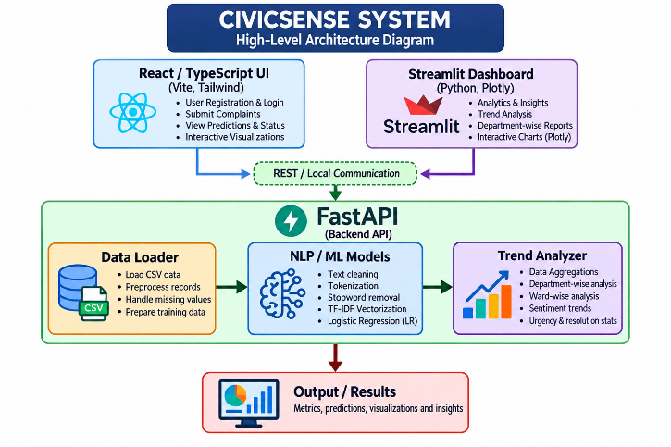Figure 4.1: Logical high-level architecture of CivicSense. The React frontend may use its embedded TypeScript ML engine or connect to the local FastAPI backend. The Python Streamlit dashboard is a separate interface that uses the Python analytics implementation.

4.2 Description of Each Layer

Presentation Layer
The presentation layer contains the React pages and the Streamlit dashboard. It displays dataset summaries, complaint classification, sentiment predictions, trend charts, model metrics and insights.

Application / API Layer
FastAPI receives requests, validates request data through Pydantic models, invokes the relevant data or model component and returns JSON responses. CORS middleware is configured for local frontend origins.

Data and Processing Layer
The data loader reads the grievance CSV and validates its schema. Preprocessing functions clean text and inspect dataset quality. Separate classifier and sentiment-analyser classes train and predict using TF-IDF and Logistic Regression. Trend analysis computes temporal and categorical summaries.

4.3 Deployment Architecture
The repository supports local development deployment. The React application runs through Vite, the FastAPI backend runs through Uvicorn, and the Streamlit dashboard runs through Streamlit. These processes can be started independently in separate terminals. Cloud hosting or a production deployment is not demonstrated by the uploaded project files.
Frontend: npm install
npm run dev
http://localhost:3000
FastAPI: cd backend
uvicorn main:app --reload --host 127.0.0.1 --port 8000
http://127.0.0.1:8000/docs
Streamlit: cd backend
streamlit run streamlit_app.py
http://localhost:8501

CHAPTER 5
DESIGN

5.1 System Workflow
Start
|
Load grievance CSV / demo data
|
Validate schema and inspect quality
|
Clean complaint text and dataset
|
TF-IDF feature extraction
|
Train / load classification models
|
Predict category and sentiment
|
Aggregate records by date, category,
ward, department, status and urgency
|
Display dashboard, trends and insights
|
End

5.2 Data Flow Diagram – Level 0
[Dataset / Analyst]
|
| CSV records or complaint text
v
+--------------------------------------+
| CIVICSENSE |
| Data validation, NLP, ML and analytics|
+--------------------------------------+
|
| Predictions, metrics, trends,
| dataset quality and insights
v
[Analyst / Dashboard User]

5.3 Data Flow Diagram – Level 1
[CSV Input]
|
v
(1) Data Loader -----> (2) Quality Inspection
|
v
(3) Data Cleaning
|
v
(4) Text Preprocessing
|
v
(5) TF-IDF Vectorization
|
+-----------+-----------+
| |
v v
(6) Category Model (7) Sentiment Model
| |
+-----------+-----------+
|
v
(8) Trend / Insight Analysis
|
v
[Dashboard / API Output]

5.4 Dataset Description and Data Dictionary
The supplied backend dataset contains 80 records and 9 columns. It has 8 service categories and 3 sentiment labels. In the supplied CSV, all 80 rows have values in the nine listed columns and no exact duplicate rows were detected.
Field | Description | Example / type
id | Unique grievance identifier | GRV-2026-001
complaint_text | Free-text citizen grievance | Text
category | Public-service category label | Roads
sentiment | Sentiment label | Negative
date | Date associated with grievance | YYYY-MM-DD
ward_or_region | Geographical ward or region | Ward 12 - Bowrampet
department | Responsible service department label | Municipal Roads Division
status | Grievance progress label | Open / In Progress / Resolved
urgency | Priority or urgency label | Low / Medium / High / Critical

5.5 Dataset Distribution
Dataset property | Observed value in supplied CSV
Number of records | 80
Number of columns | 9
Missing cells | 0
Exact duplicate rows | 0
Unique categories | 8
Unique sentiment labels | 3
Date range | 2026-08-01 to 2026-09-24

Category | Record count
Drainage / Sewage | 10
Education | 10
Electricity | 10
Healthcare | 10
Other Public Services | 10
Roads | 10
Transportation | 10
Water Supply | 10

Sentiment | Record count
Negative | 39
Positive | 28
Neutral | 13

5.6 Database Schema / Storage Design
The present implementation uses a CSV dataset as its primary supplied data source and keeps working records in application memory. The following logical record structure describes the CSV fields; it is not a claim that a database table has been created.
GrievanceRecord
----------------
id : string
complaint_text : string
category : string
sentiment : string
date : date/string
ward_or_region : string
department : string
status : string
urgency : string
priority_score : optional numeric field in frontend type

CHAPTER 6
IMPLEMENTATION

6.1 Module-wise Implementation
Module | Implementation description
Data Management | Loads CSV records, validates the required complaint_text field, checks recommended columns, reports warnings and supports cleaning/reset operations.
Text Preprocessing | Lowercases text, removes URLs and email addresses, removes punctuation and isolated digits, tokenizes text and removes common English stopwords.
Complaint Classification | Uses TF-IDF features and Logistic Regression to predict one of eight public-service categories.
Sentiment Analysis | Uses a separate TF-IDF and Logistic Regression model to predict Positive, Negative or Neutral sentiment.
Model Evaluation | Computes accuracy, weighted and macro precision, recall and F1-score, confusion matrix and classification report; training code also includes cross-validation and baseline comparison.
Trend Analysis | Summarizes daily, weekly and monthly complaint counts, category and sentiment distributions, keywords and phrases, department and ward metrics, resolution statistics and duplicate candidates where available.
Insights | Produces summary metrics and automated insight messages based on grievance patterns.
Complaint Explorer | Allows users to inspect complaint records with category, sentiment, status and text-search filters.
API Service | Exposes backend operations through FastAPI endpoints and JSON responses.

6.2 Front-end Logic and State Management
The React application is organized into pages and reusable components. The CivicContext provider maintains the active navigation tab, grievance records, selected model, backend mode, dataset quality, trends, insights, model metrics, notifications and explorer filters. The API service attempts to call FastAPI when local backend mode is selected and can fall back to the embedded TypeScript ML engine when the backend is unavailable.

6.3 Backend Logic
The backend entry point is backend/main.py. It creates a FastAPI application, configures CORS, initializes a DataLoader and trains the Logistic Regression category and sentiment models when a usable dataset is available. Pydantic request models validate incoming text, including minimum and maximum text length constraints.

6.4 Machine Learning Methodology

6.4.1 Text Preprocessing
- Convert complaint text to lowercase.
- Remove web links and email addresses.
- Remove punctuation and special characters.
- Remove isolated numeric tokens.
- Split the text into tokens.
- Remove common English stopwords and very short tokens.

6.4.2 TF-IDF Vectorization
TF-IDF represents each complaint as a numerical vector. Term Frequency measures how often a term appears in a document. Inverse Document Frequency reduces the weight of terms that occur in many documents. The implementation uses unigram and bigram features (ngram_range = (1, 2)) and limits the vocabulary size. The backend classifier uses a maximum of 1,500 features for category classification and 1,200 for sentiment classification.
A simplified expression is:
TF-IDF(t, d) = TF(t, d) × IDF(t)
The vectorizer is fitted only on the training split and then applied to the test split. This helps prevent information from the test set leaking into feature construction.

6.4.3 Logistic Regression
Logistic Regression is a supervised learning algorithm used for classification. It estimates class probabilities from input features and selects the most likely class. CivicSense uses Logistic Regression as its primary algorithm, with maximum iterations set to 1,000 and balanced class weights in the Python backend.
The category model predicts one of eight service areas. The sentiment model is trained separately and predicts one of three sentiment labels. The code also includes Multinomial Naive Bayes as a comparison baseline; the primary API configuration uses Logistic Regression.

6.4.4 Model Evaluation
The backend separates data into training and testing partitions using a 75:25 split by default. Where class counts permit, stratified splitting is attempted. Evaluation includes accuracy, precision, recall, F1-score and confusion matrix. Actual numerical model scores must be taken from a run of the application on the final dataset and entered in the results table in Chapter 8.

6.5 Database Connectivity
No external database connection is present in the inspected project. The CSV is loaded using Pandas, and records are maintained in memory during application execution. A database-backed persistent storage layer can be considered as a future enhancement.

6.6 API Integration
HTTP method | Endpoint | Purpose
GET | /api/health | Check backend health, model readiness and loaded record count
GET | /api/dataset | Retrieve paginated grievance records with optional filters
POST | /api/upload-csv | Upload a CSV dataset
POST | /api/clean-data | Clean the active dataset
POST | /api/reset-demo | Restore the default demo dataset
POST | /api/classify-complaint | Predict the service category for complaint text
POST | /api/analyze-sentiment | Predict sentiment for complaint text
GET | /api/trends | Retrieve trend analytics
GET | /api/model-evaluation | Retrieve model evaluation metrics
GET | /api/insights | Retrieve automated civic insights

6.7 Authentication and Authorization
The inspected source does not implement user login, role-based access control or token-based authentication. The system is intended for local academic demonstration in its current form. Authentication, authorization, audit logs and secure user management should be added before any public or production deployment.

CHAPTER 7
FEATURES

7.1 Main Features
- Dataset upload and validation for CSV grievance data.
- Dataset quality inspection, including missing-value and duplicate counts.
- Automated cleaning of duplicate rows and selected missing or malformed values.
- Eight-class complaint category prediction.
- Three-class sentiment prediction.
- Model evaluation with confusion matrices and standard classification metrics.
- Daily, weekly and monthly complaint trend analysis.
- Category, sentiment, department and ward comparisons.
- Complaint explorer with filters and search.
- Automated insights and priority-oriented summaries.
- Backend status selection between embedded ML and local FastAPI modes.

7.2 How Each Feature Works
A user begins with the demo dataset or uploads a CSV file. The application checks whether the required complaint_text column is available and validates the dataset. The data-management page displays the quality summary and provides cleaning controls.
For complaint analysis, the user enters complaint text or selects a demonstration example. The text is cleaned and transformed into TF-IDF features. The trained category model returns the predicted public-service category and confidence information. The sentiment module independently returns a sentiment label and associated probabilities.
The analytics pages aggregate the active records. Charts show changes over time and distributions across categories and sentiments. The complaint explorer supports inspection of individual records, while the insights module presents generated summaries and action-oriented observations.

7.3 User Interface Pages
Page / module | Purpose
Landing / Home | Introduces CivicSense and provides entry to the analytics workspace.
Dashboard | Displays overall grievance indicators and summary charts.
Data Management | Imports CSV data, inspects quality, cleans records and resets demo data.
Complaint Analysis | Predicts a complaint's public-service category.
Sentiment Analysis | Predicts Positive, Negative or Neutral sentiment.
Trend Analysis | Displays temporal patterns, category and sentiment trends.
Complaint Explorer | Searches and filters individual grievance records.
Model Evaluation | Displays model metrics and confusion matrices.
Insights | Shows summary indicators and automated civic insights.

CHAPTER 8
TESTING

8.1 Testing Strategy
Testing should verify data validation, text preprocessing, model training and prediction, API behavior and integration between the user interface and backend. The repository includes a Pytest test suite covering preprocessing, schema validation, model training and FastAPI endpoints. The report below describes the test plan; mark each result only after executing the tests in the submission environment.

8.2 Test Cases and Expected Results
Test ID | Test objective | Test input / action | Expected result
TC-01 | Load supplied CSV | Load demo_grievances.csv | 80 records and 9 columns are read
TC-02 | Inspect missing values | Run dataset-quality inspection | Missing-cell count is reported
TC-03 | Detect duplicates | Run duplicate inspection | Duplicate count is reported
TC-04 | Clean text | Input text containing URL and punctuation | Noise is removed and useful words remain
TC-05 | Empty text | Submit empty or whitespace-only text | Empty cleaned string / validation response
TC-06 | Category prediction | Submit a valid civic complaint | One of the eight categories is returned
TC-07 | Sentiment prediction | Submit a valid complaint | Positive, Negative or Neutral is returned
TC-08 | Health endpoint | GET /api/health | Health status and model readiness are returned
TC-09 | Dataset endpoint | GET /api/dataset | Paginated JSON records are returned
TC-10 | CSV validation | Upload a CSV without complaint_text | Validation error is returned
TC-11 | Trend endpoint | GET /api/trends | Trend summary is returned
TC-12 | Model evaluation | GET /api/model-evaluation | Evaluation metrics are returned when models are trained

8.3 Tools Used for Testing
- Pytest – backend unit and regression tests.
- FastAPI Swagger UI (/docs) – manual API request and response checks.
- Web browser – frontend interaction and display verification.
- Manual CSV inspection – checking dataset structure and sample records.

8.4 Test Execution and Results
The repository contains automated tests, but no test-execution log or verified pass count was supplied with the project archive. Execute the command below and replace the placeholders with the actual terminal output before final submission.
cd backend
pytest tests/ -v
Metric | Final value to be filled after execution
Total tests collected | [Enter result]
Tests passed | [Enter result]
Tests failed | [Enter result]
Test execution date | [Enter date]
Category model accuracy | [Copy actual application metric]
Sentiment model accuracy | [Copy actual application metric]

CHAPTER 9
DEPLOYMENT

9.1 Steps to Deploy Locally

9.1.1 Run the React Frontend
cd civicsense-main
npm install
npm run dev
Open http://localhost:3000 in a browser. The project uses Vite and the development server is configured on port 3000.

9.1.2 Run the FastAPI Backend
cd civicsense-main\backend
python -m venv venv
.\venv\Scripts\Activate.ps1
pip install -r requirements.txt
uvicorn main:app --reload --host 127.0.0.1 --port 8000
Open http://127.0.0.1:8000/docs to view and test the API endpoints.

9.1.3 Run the Streamlit Dashboard
cd civicsense-main\backend
streamlit run streamlit_app.py
Open the local URL printed by Streamlit, normally http://localhost:8501.

9.2 Environment Configuration
Use a Python virtual environment to isolate backend dependencies. Install Node dependencies from the project root, where package.json is located. If the FastAPI service is used, select the local FastAPI backend mode in the frontend and confirm that the health endpoint is reachable. The backend CORS configuration includes local development origins.

9.3 Hosting of Frontend and Backend
The uploaded repository documents local execution only. A public deployment would require selecting hosting platforms, configuring environment variables and allowed origins, serving the API over HTTPS, securing uploaded datasets, monitoring the service and arranging persistent storage. These production steps are recommendations and have not been claimed as completed.

CHAPTER 10
CHALLENGES AND LIMITATIONS

10.1 Issues Considered During Development
- Citizen complaints are unstructured and may contain spelling variations, punctuation, URLs and irrelevant words.
- Some categories or sentiment classes may have fewer training examples than others.
- Text classification can be uncertain when a complaint mentions multiple services or lacks context.
- Frontend and backend can run as separate local processes, so the API connection must be configured correctly.
- CSV files supplied by users may have missing columns, invalid labels or incomplete text.

10.2 Solutions Applied
- Text normalization and stopword removal are applied before vectorization.
- Schema validation checks the required complaint_text field and reports missing recommended fields.
- Balanced class weights are configured for the Logistic Regression models.
- The vectorizer is fitted only on training data to reduce test-data leakage.
- The frontend supports an embedded ML mode and a local FastAPI mode, with fallback behavior in the API service.

10.3 Current Limitations
- The supplied backend CSV is a small demonstration dataset of 80 records; it is not evidence of performance on all real-world civic complaints.
- Model quality depends on the accuracy, representativeness and balance of labelled training examples.
- English stopword-based preprocessing may not handle regional languages, code-mixed text or local spellings effectively.
- Predictions are statistical estimates and may require human review, especially for ambiguous or urgent complaints.
- The inspected project does not connect to a live government grievance platform or dispatch tasks to government departments.
- No persistent database, citizen authentication or production authorization workflow is evidenced in the submitted files.
- Cloud deployment and operational security have not been demonstrated in the supplied repository.

CHAPTER 11
FUTURE ENHANCEMENTS

11.1 Planned Features
- Expand the dataset using verified, anonymized and appropriately licensed public grievance records.
- Add support for Telugu, Hindi and other regional languages, including code-mixed text.
- Introduce a secure citizen-facing complaint submission and tracking portal.
- Add administrator roles, authentication, authorization and audit logging.
- Integrate a persistent database for complaint records and model outputs.
- Connect to authorized municipal or government APIs where formal access is available.
- Add location-aware maps and department-level service dashboards.
- Provide model monitoring, retraining workflows and drift checks.

11.2 Possible Integrations and Optimizations
The system can be extended with transformer-based language models for richer text understanding, subject to dataset size and compute availability. Explainability methods can show influential words behind a prediction. A human-in-the-loop review process can collect corrections and improve training labels. Production deployment should include encryption, privacy controls, secure file validation, rate limiting, monitoring and backup policies.

CHAPTER 12
CONCLUSION

12.1 Summary of the Project
CivicSense demonstrates a data science workflow for analysing public grievances. It combines dataset validation, text preprocessing, TF-IDF feature extraction, supervised text classification, sentiment analysis and visual analytics. The project provides both a web-based React interface and Python-based backend/dashboard options.

12.2 What Was Achieved
- A structured grievance dataset format was defined and a demo CSV dataset was included.
- Text preprocessing was implemented for complaint descriptions.
- Separate category and sentiment classification components were implemented.
- Model evaluation logic was included using standard classification metrics.
- Trend analysis and automated insight modules were implemented.
- FastAPI endpoints were provided to expose backend functionality.
- Interactive interfaces were created for dataset management, complaint analysis and visualization.

12.3 Skills Learned During Development
- Understanding the data science lifecycle from data loading to interpretation.
- Preparing and validating structured datasets using Pandas.
- Applying NLP preprocessing and TF-IDF vectorization.
- Training and evaluating supervised machine-learning classifiers.
- Building API services using FastAPI and integrating frontend applications.
- Designing dashboards and interpreting data visualizations.
- Testing Python modules and documenting software systems.

CHAPTER 13
REFERENCES
- Pedregosa, F. et al. (2011). Scikit-learn: Machine Learning in Python. Journal of Machine Learning Research, 12, 2825–2830.
- Scikit-learn documentation: https://scikit-learn.org/stable/
- Python documentation: https://docs.python.org/3/
- Pandas documentation: https://pandas.pydata.org/docs/
- NumPy documentation: https://numpy.org/doc/
- FastAPI documentation: https://fastapi.tiangolo.com/
- Streamlit documentation: https://docs.streamlit.io/
- React documentation: https://react.dev/
- TypeScript documentation: https://www.typescriptlang.org/docs/
- Vite documentation: https://vite.dev/guide/
- Plotly Python documentation: https://plotly.com/python/
- Matplotlib documentation: https://matplotlib.org/stable/
- Pytest documentation: https://docs.pytest.org/
Also refer to the CivicSense source code, README files, backend requirements file and supplied demo_grievances.csv dataset.

CHAPTER 14
APPENDICES

14.1 Screenshots of the Application
Insert actual screenshots captured from the running CivicSense application. Use clear images with figure numbers and captions. Do not use mock screenshots as evidence of implemented functionality.
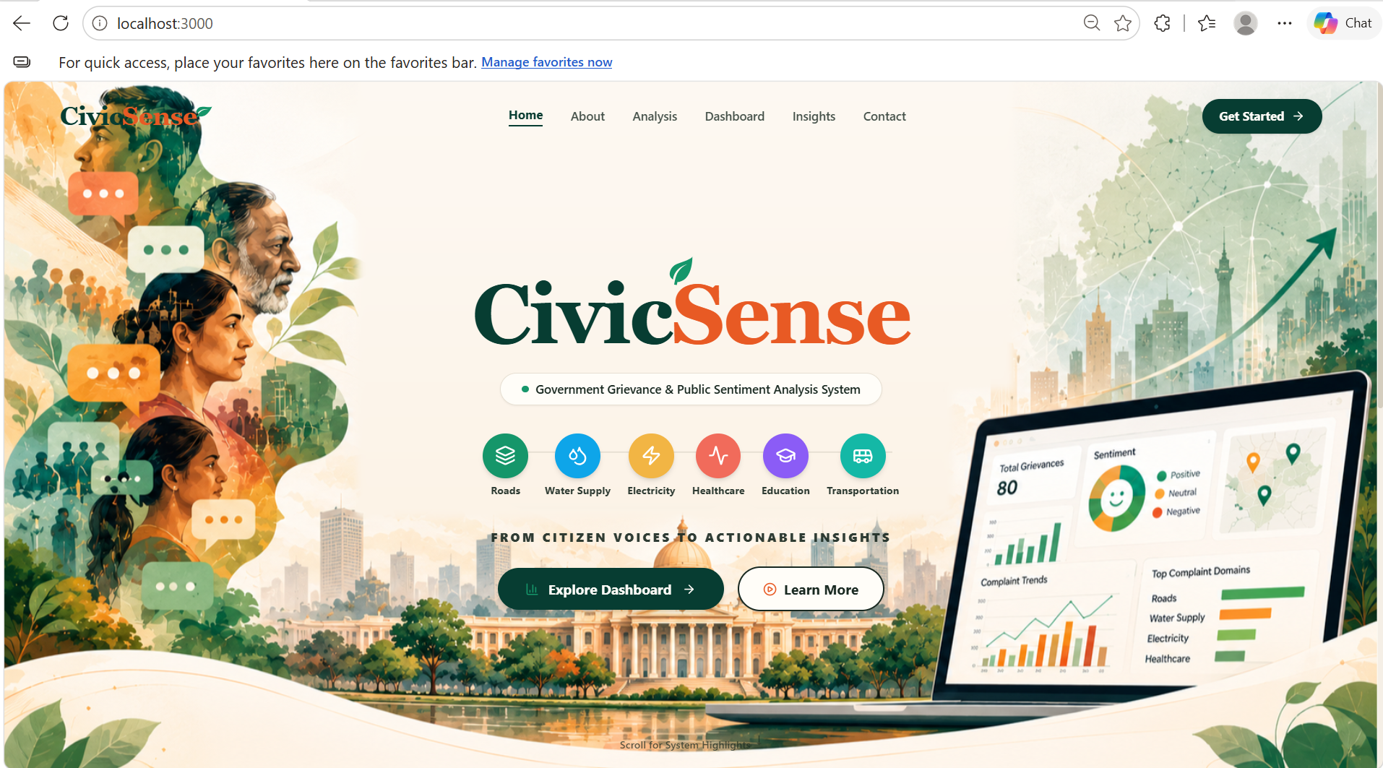
Figure A.1 – CivicSense landing page
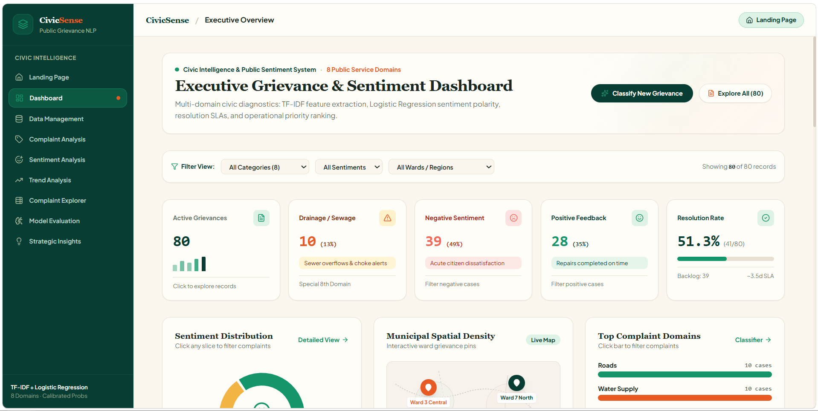
Figure A.2 – Main dashboard
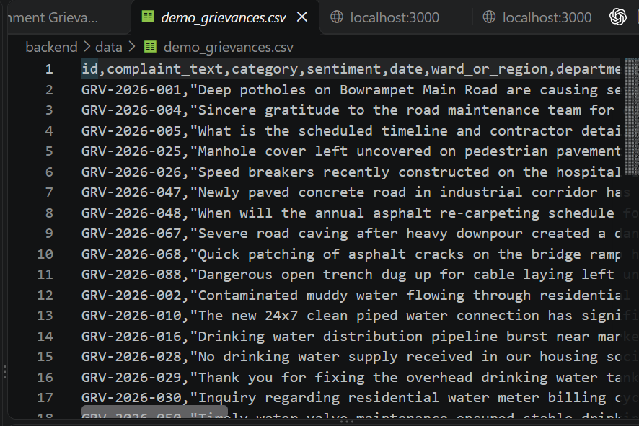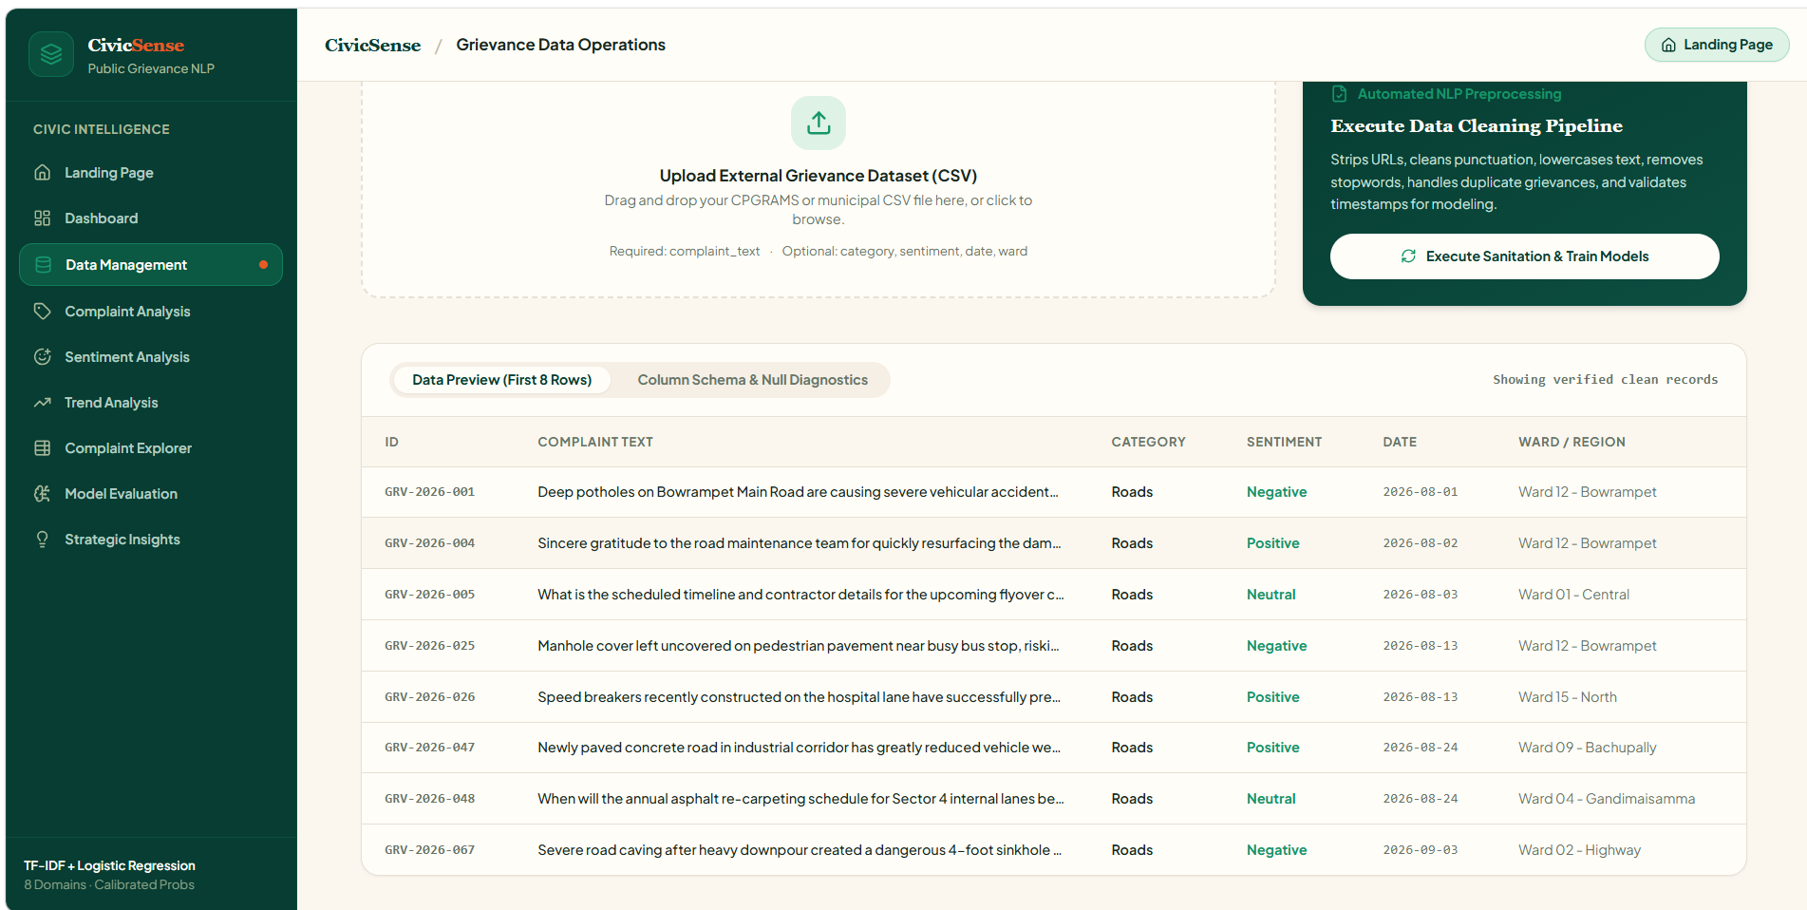
Figure A.3 – Data management and dataset quality view
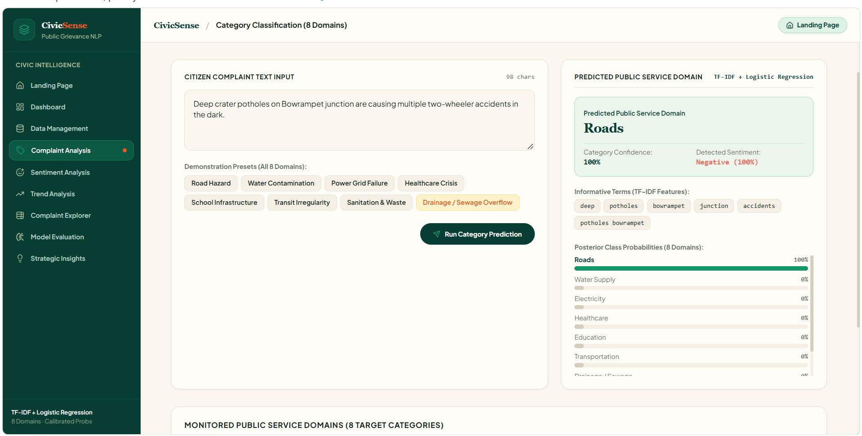
Figure A.4 – Complaint category prediction
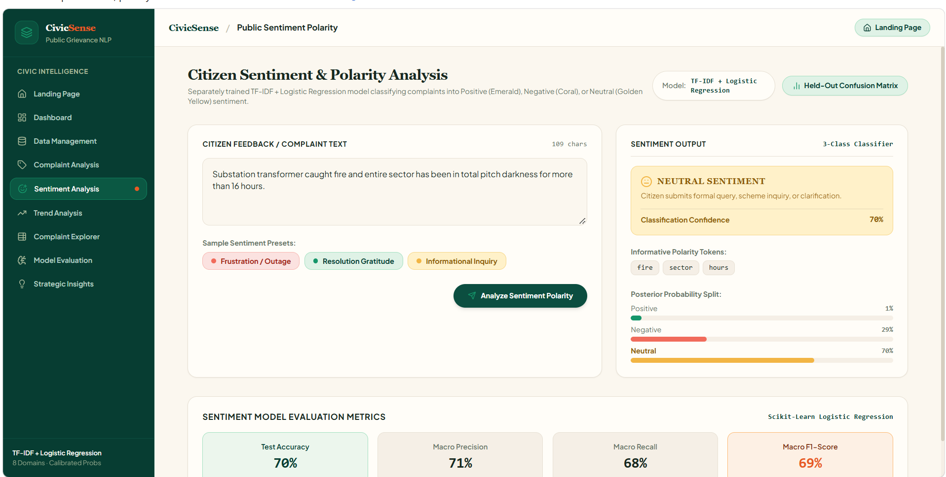
Figure A.5 – Sentiment analysis result
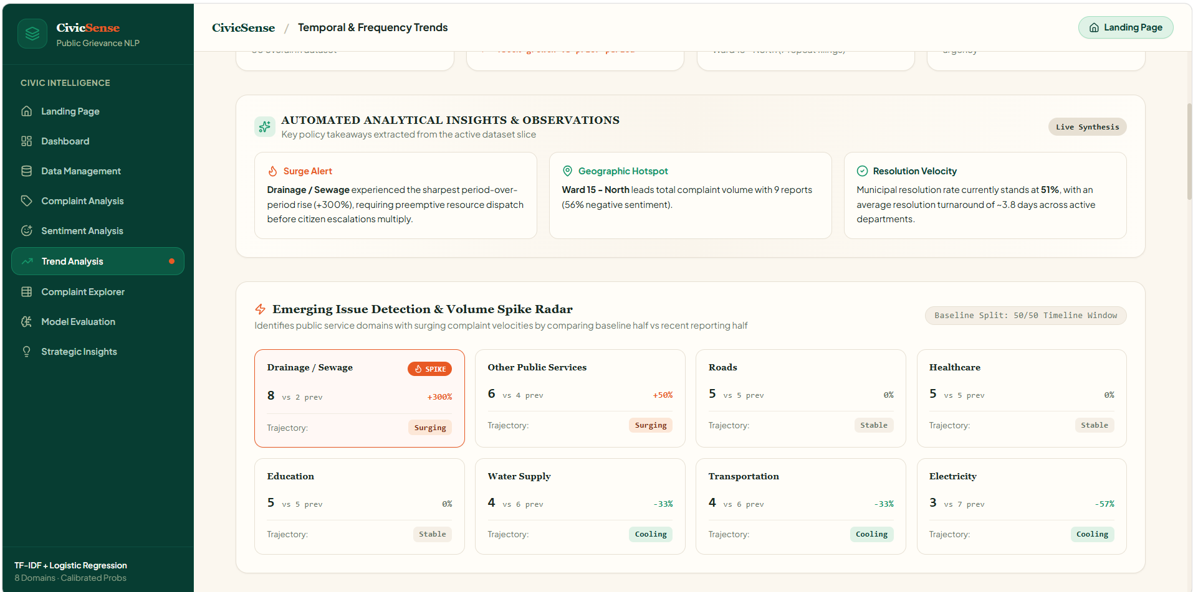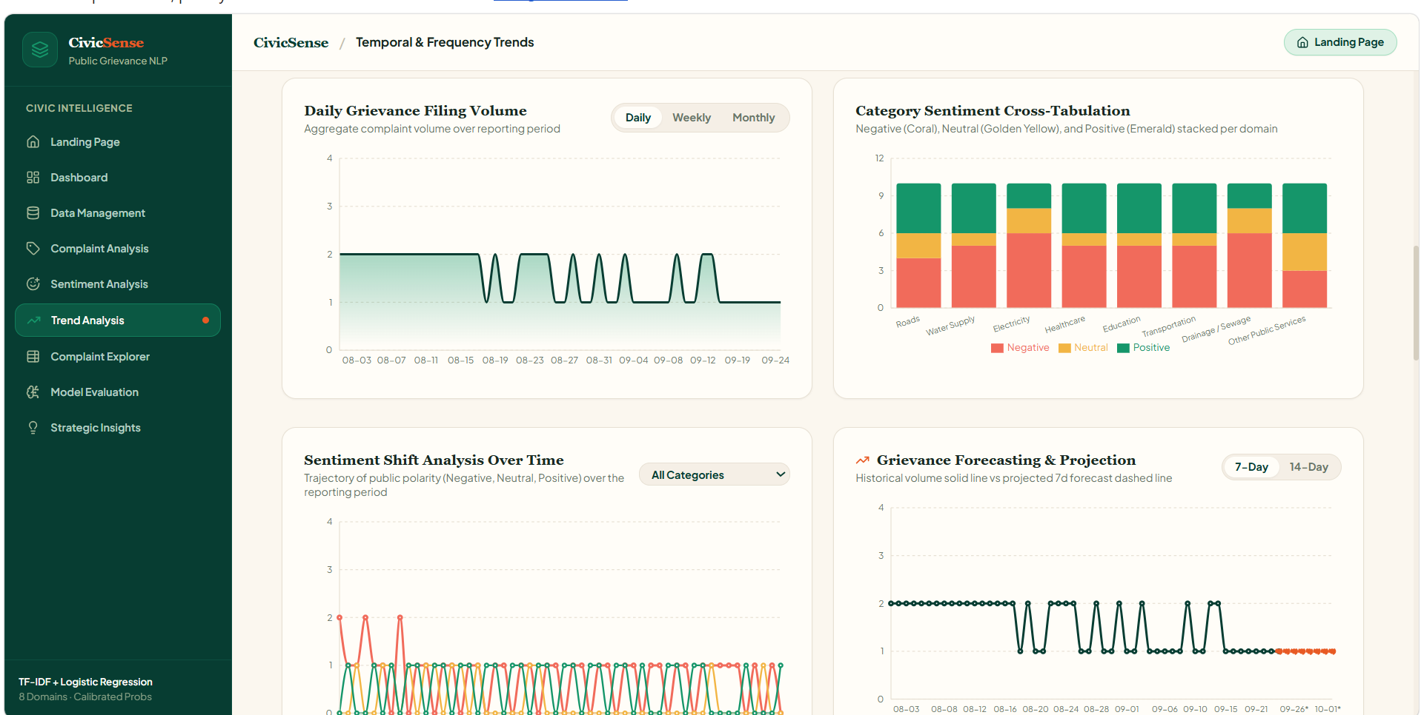
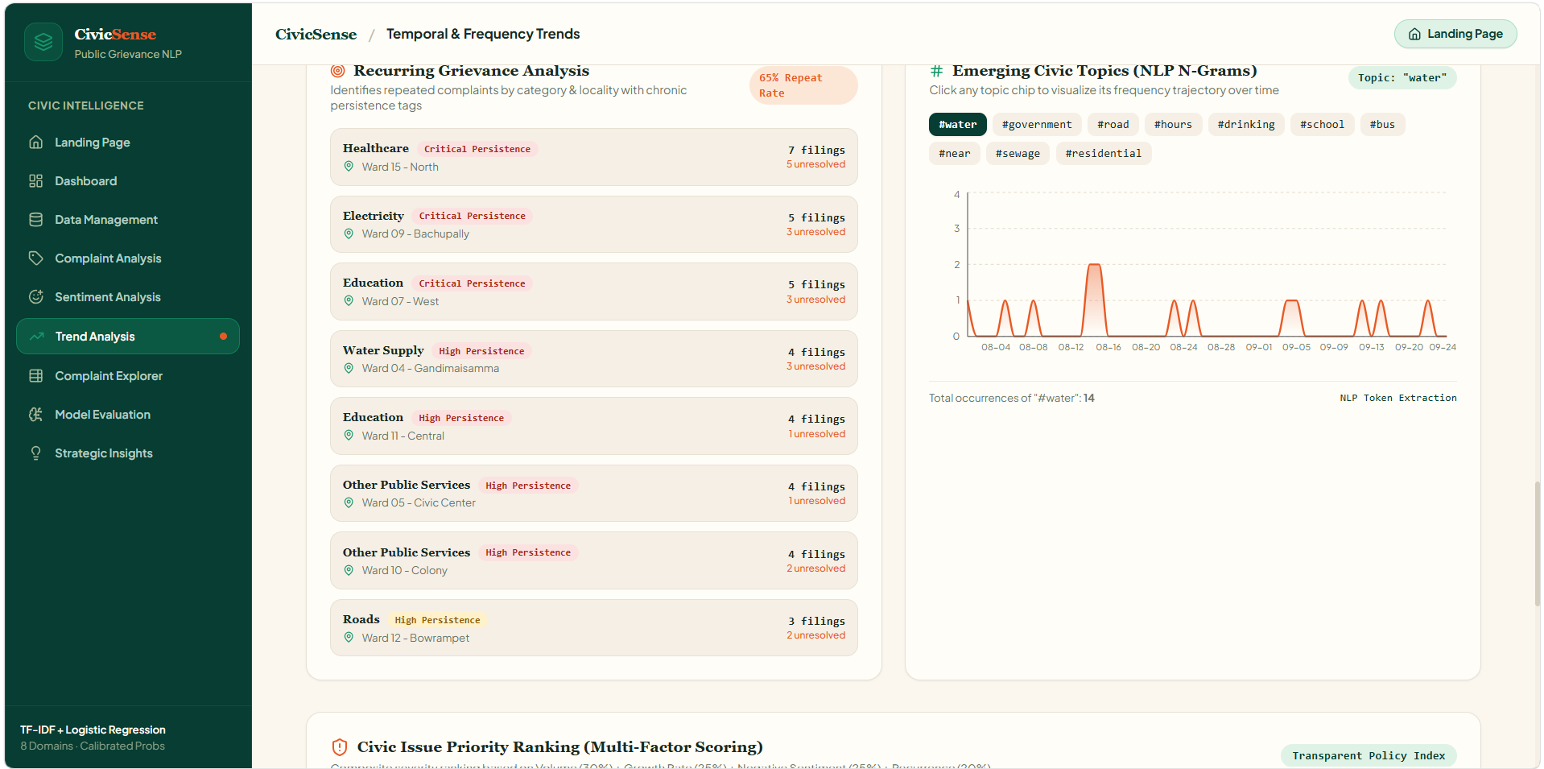
Figure A.6 – Trend analysis charts
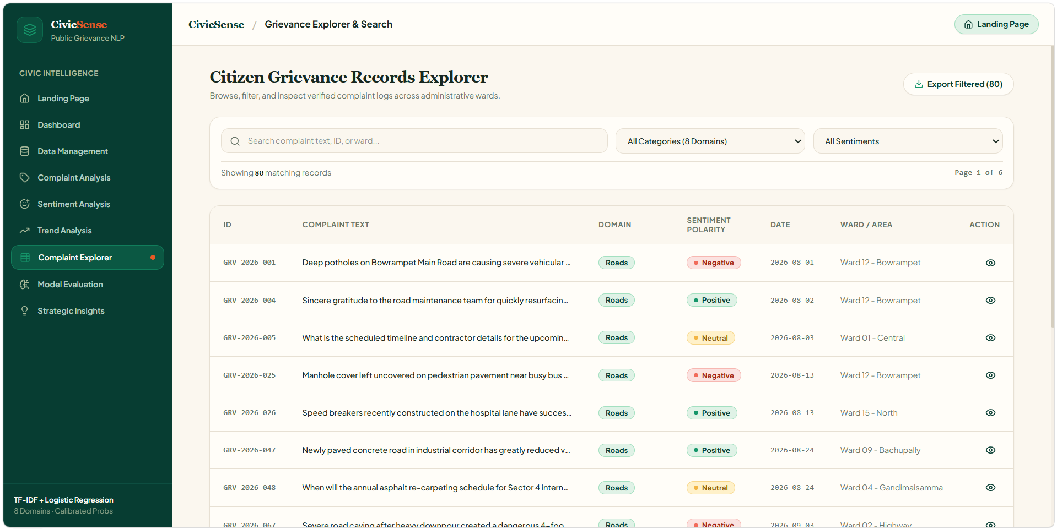
Figure A.7 – Complaint explorer and filters
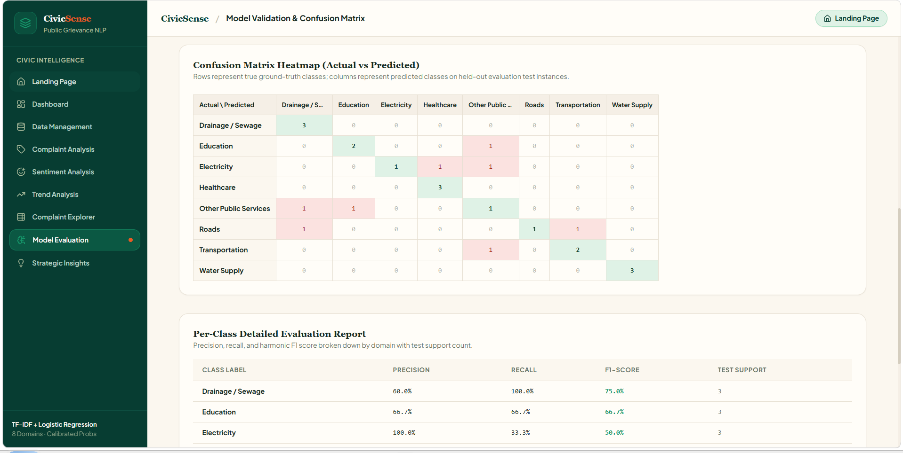
Figure A.8 – Model evaluation and confusion matrix

14.2 Sample Code Snippets
Text cleaning logic (simplified representation from the backend preprocessing module):
def clean_text(text):
if not isinstance(text, str) or not text.strip():
return ""
text = text.lower()
text = re.sub(r"https?://\\S+|www\\.\\S+", "", text)
text = re.sub(r"\\S+@\\S+", "", text)
text = text.translate(str.maketrans("", "", string.punctuation))
tokens = text.split()
tokens = [w for w in tokens if w not in STOPWORDS and len(w) > 2]
return " ".join(tokens)
Model training workflow (conceptual):
cleaned_text = complaint_text.apply(clean_text)
X_train, X_test, y_train, y_test = train_test_split(
cleaned_text, labels, test_size=0.25, random_state=42
)
X_train_vec = vectorizer.fit_transform(X_train)
X_test_vec = vectorizer.transform(X_test)
model.fit(X_train_vec, y_train)
predictions = model.predict(X_test_vec)

14.3 Installation and Setup Instructions
Frontend dependencies are installed from the root folder using npm install. Backend dependencies are installed inside backend after creating and activating a Python virtual environment using pip install -r requirements.txt. Run the frontend, FastAPI backend and Streamlit dashboard in separate terminals as required.

14.4 User Manual
- Open the application in the browser after starting the frontend or Streamlit dashboard.
- Load the demo dataset or upload a supported CSV file.
- Review the dataset-quality summary and run cleaning if required.
- Open Complaint Analysis and enter a complaint or choose a demonstration preset.
- Open Sentiment Analysis to view the sentiment prediction.
- Use Trend Analysis and Dashboard to review aggregated patterns.
- Use Complaint Explorer to search and filter grievance records.
- Open Model Evaluation to inspect the current model metrics.
- Use the Insights page to read generated summaries.
- If using the FastAPI mode, start the backend first and confirm the backend health status.

